

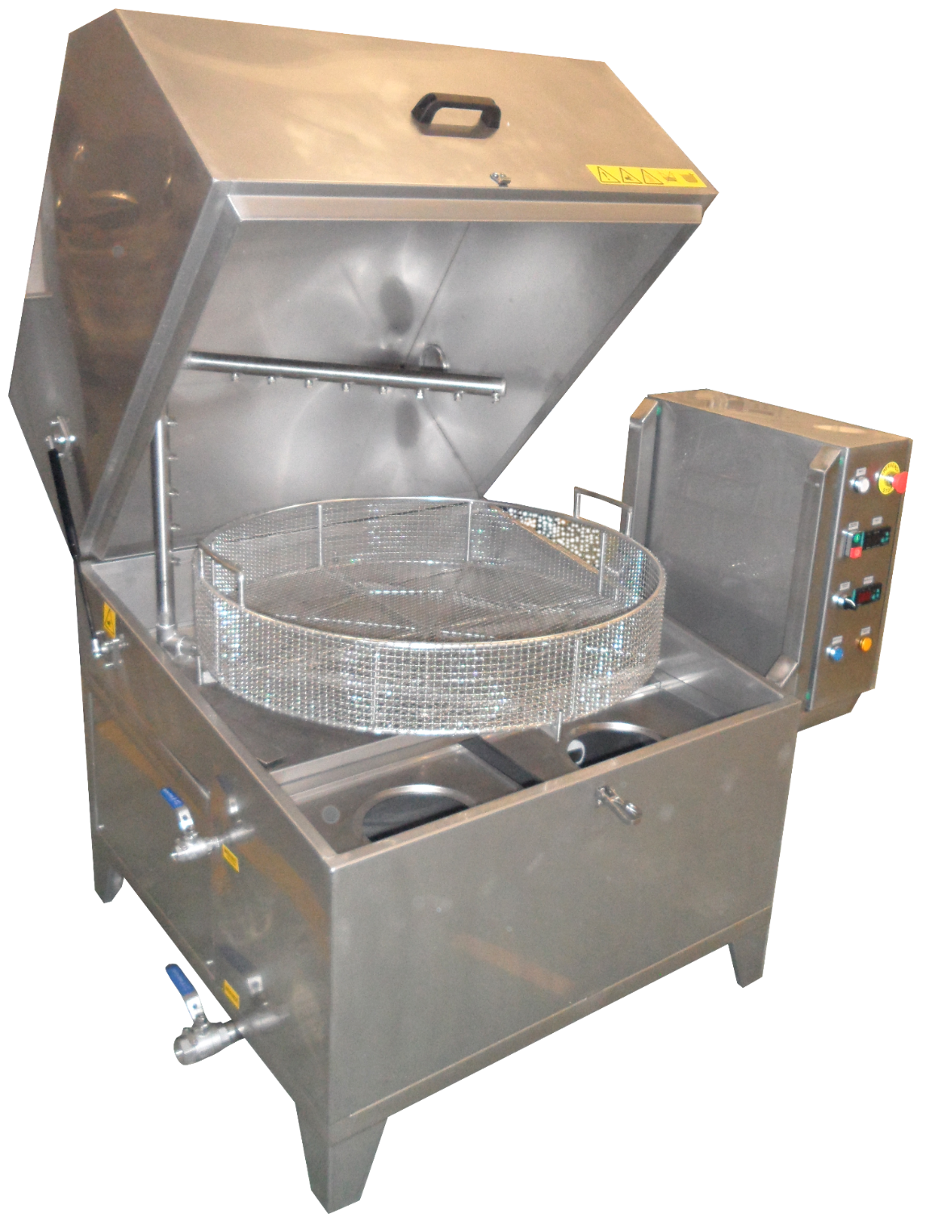

**USER MANUAL**

**ESP 82**

|  |  |  |
| --- | --- | --- |
| **PATH** | **INDEX** | **PAGE** |
| **1** | Product Details…………………………………………… | 3 |
| **2** | Safety Instructions………………………………………. | 4 |
| **3** | Machine Parts………………………………………..……. | 5 |
| **4** | Control Panel………………………………………………. | 9 |
| **5** | Installation And Usage Of Machine …………….... | 12 |
| **6** | Machine Maintenance………………………………….. | 13 |
| **7** | Instructions For Problems…………………………… | 14 |
| **8** | Recommendations ……………………………………… | 15 |
| **9** | Attentions…………………………………………………... | 15 |
| **-** | Certificate Of Guarantee………………………………. | 16 |
| **-** | EC Declaration Of Conformity………………………. | 17 |

|  |  |
| --- | --- |
| Everest Elektromekanik Makine Ve Sistemleri Sanayi Ve Tic. Ltd. Şti.  Bağcılar-Güngören Sanayi Sitesi Metro İş Merkezi A Blok No: 6-9 Başakşehir /İstanbul  Tel:+90(212) 671 25 85 Fax:+90(212) 671 25 89  http://www.everestultrasonic.com E-mail:info@everestultrasonic.com |  |

**1- PRODUCT DETAILS**

**WARNING**! Do Not Use Your Machine Before Reading Operating Manual. EVEREST ELEKTROMEKANİK Is Not Responsible For Incorrect Usage.

|  |  |
| --- | --- |
| EXTERNAL DIMENSIONS (Mm) (Width*Length*Height) | 1200 x 950 x 1130 |
| Total Power (400 Volt / 50 Hz) | 6 kW |
| Stainless Steel Circulation Pump | LOWARA CEA 120/5/A |
| Stainless Steel Construction | Tank: AISI 304 Stainless Steel, 1,5 mm  External Covers: AISI 304 Stainless Steel, 1 mm  Body: AISI 304 Stainless Steel, 1,5mm  Structural Frame: AISI 304 Stainless Steel,40x40x1,5 mm |
| Basket Diameter | 820 mm |
| Maximum Part Height | 400 mm |
| Load Capacity | 150 kg |
| Low Water Level Protection | YES |
| Tank Capacity | 120 lt. |
| Machine Weight | 200 kg |
| Draining | 1” Spherical Valve |
| Water inlet | ½” Spherical Valve |
| Heating | 4,5 KW Resistance. They Are Easily Plug/Unplugged From The Outside Of Tank. They Are Made From 316 L Stainless Steel. |

Machine Dimensions Are Shown Below.

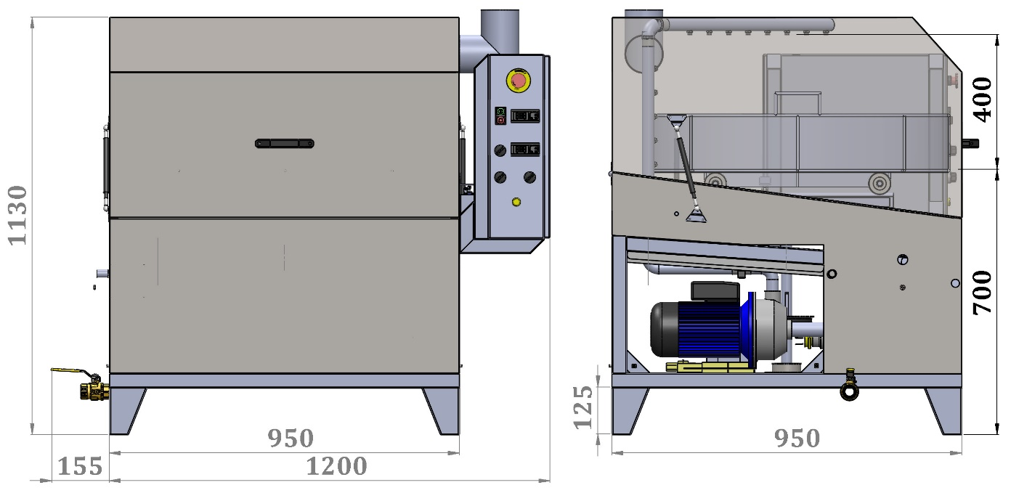

**2-SAFETY INSTRUCTIONS**

* Emergency Button On The Control Panel. If There Is Something Going Wrong Please Push The Button To Stop The Machine.
* When The Machine Is Running Please Do Not Open The Lids.
* Please Don’t Touch The Hot Surface By Naked Hand. You Will See That Warnings On The Hot Surfaces. https://encrypted-tbn0.gstatic.com/images?q=tbn:ANd9GcSCVQk-zAQWgynn9-sN-J5-Jm8FvfFwdKyazDF9h4FwDto5vYuSww
* When The Machine Is Running Be Careful Against To Steam And Hot Air.
* Do Not Push The Buttons With A Sharp Or Prickle Object.
* If There Is Any Problem Please Contact The Service Person Who Is Responsible From The Machine Service.
* Machine Operator Must Take Care Of The Other People Who Are Standing Near The Machine.
* Operators Must Read User Manual Before Operating The Machine
* Before Starting The Machine Please Check Once More The Connections Such As Electrical Connections, Water Connections, Air Connection.
* P.P.E (Personal Protection Equipment) Has To Wear Before Operating The Machine.
* Supplying Cables Have To Be Protected According To Rules And Regulations.
* Electricity, Plugs And Sockets Have To Be Earthed.
* There Has To Be Enough Lighting For Safe Working.

***Attention!!!***

*After The Unpacking The Machine Please Check Again The Fitting Connections, Nuts, Screws, Valves, U.S Module Nut… Etc. Which Has Possibility To Loosening. Because During The Transportation Machines Expose To Vibrations. After Checking And Fixing That Connection To Can Start To Installation.*

*If You Have Any Problem Please Do Not Hesitate To Contact With Us.*

**3- MACHINE PARTS**

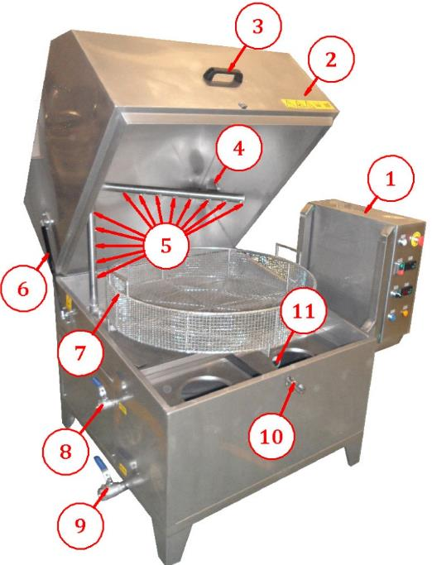

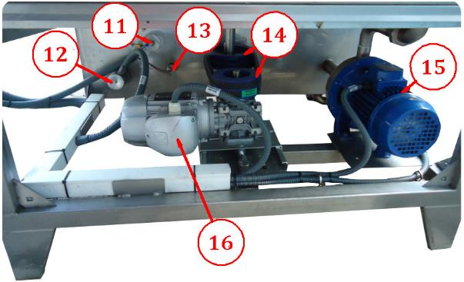

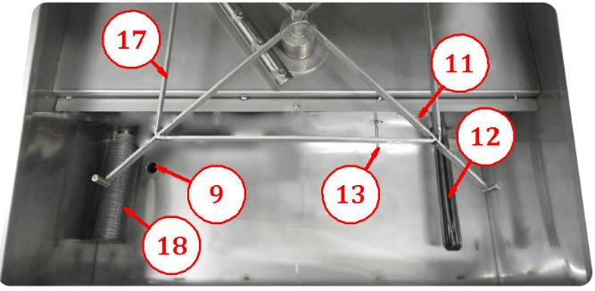

|  |  |  |  |
| --- | --- | --- | --- |
| **No** | **Component Name** | **MARK** | **CODE** |
| **1** | Control Panel | EVEREST | - |
| **2** | Lid | EVEREST | - |
| **3** | Lid Handle | - | - |
| **4** | Vapor Outlet | EVEREST | - |
| **5** | Nozzles | LECHLER | 632.604.16.CC |
| **6** | Shock Absorber | EVEREST | 8-18/260-390/380N |
| **7** | Basket | EVEREST | ∅850 |
| **8** | Water Inlet | SPHERICAL VALVE | ½” |
| **9** | Drain Pipe | SPHERICAL VALVE | 1” |
| **10** | Lid Locking Latch | - | - |
| **11** | Low Level Sensor | TELEMECANIQUE | RM35LM |
| **12** | Heater | IRCA | 4,5 KW |
| **13** | Heat Sensor | EMKO | PT 100 |
| **14** | Pulleys | - | - |
| **15** | Circulation Pump | LOWARA | CEA 120/5/A |
| **16** | Basket Motor | MOTIVE | 0,13 KW 1400 rev/min |
| Basket Reducer | BOX040 63B14 I:100 |
| **17** | Rotating Platform | EVEREST | - |
| **18** | Pump Suction Mesh Filter | EVEREST | - |

***Optional Extras***

|  |  |  |
| --- | --- | --- |
| * **Bag Filter System** | | |
|  | **No** | **Description** |
| **1** | Filtration Pump  LOWARA CEA 70/3/A |
| **2** | Bag Filter - 20” 100 MCR |
| **3** | Pump Suction |
| **4** | Bag Filter Inlet-Dirty |
| **5** | Bag Filter Outlet-Clean |
| **6** | Water Tank Return |
| **7** | Tank |
| **8** | Drain Valve |

|  |  |  |
| --- | --- | --- |
| * **Cartridge Filter System** | | |
|  | **No** | **Description** |
| **1** | Filtration Pump  LOWARA CEA 70/3/A |
| **2** | Cartridge Filter - 20” 100 MCR |
| **3** | Pump Suction |
| **4** | Cartridge Filter Inlet-Dirty |
| **5** | Cartridge Filter Outlet-Clean |
| **6** | Water Tank Return |
| **7** | Tank |
| **8** | Drain Valve |

|  |  |  |
| --- | --- | --- |
| * **Oil Skimmer System** | | |
| **E:\K. Klavuzu\Yağ Sıyırıcı Opsiyonel.png** | **No** | **Description** |
| **1** | Oil Skimmer Reducer & Motor  0,09 KW - 1400 d/d - i80  MOTIVE BOX 030 56B14 |
| **2** | Oil Outlet Valve – ½” |
| **3** | Oil Collection Chamber |
| **4** | Machine Body |
| **5** | Oil Skimmer Disk - Ø 220 |

|  |  |  |
| --- | --- | --- |
| * **Loading Car** | | |
|  | **No** | **Description** |
| **1** | Loading Car Centering Pins |
| **2** | Loading Car Locking Pins |
| **3** | Basket Locking Pins |
| **4** | Loading Car & Basket Locking Handle |
| **5** | Loading Car Handle |

**4- CONTROL PANEL**

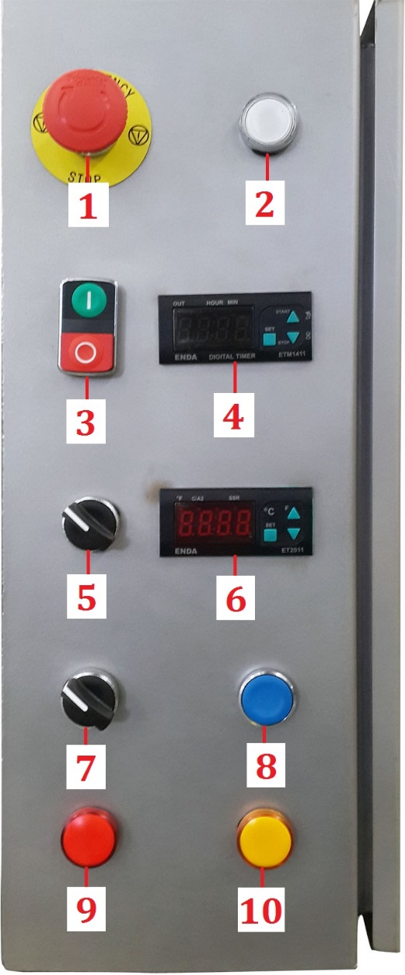

|  |  |  |  |  |
| --- | --- | --- | --- | --- |
| **No** | **Component Name** | **Mark** | **Code** | **Where is the using?** |
| 1 | Emergency Stop | Schneider | XB4-BS542 | Emergency Stop |
| 2 | Spring Button | Schneider | XB4-BW31B5 | Approval Button |
| 3 | Start-Stop | Schneider | XB4-BL73415 | Washing Start/Stop |
| 4 | Timer | Enda | ETM1411 | Washing Timer |
| 5 | 0-1 Button | Schneider | XB4-BD21 | Heater Off/On |
| 6 | Thermostat | Enda | ET 2011 | Heater Thermostat |
| 7 | 0-1 Button | Schneider | XB4-BD21 | Oil Skimmer Off/On |
| 8 | Spring Button | Schneider | XB4-BA61 | Basket Rotation |
| 9 | Lamp | Schneider | XB4-BVB4 | Thermic Fault Lamp |
| 10 | Lamp | Schneider | XB4-BVB5 | Low Level Lamp |

**COMPONENT ON BOARD**

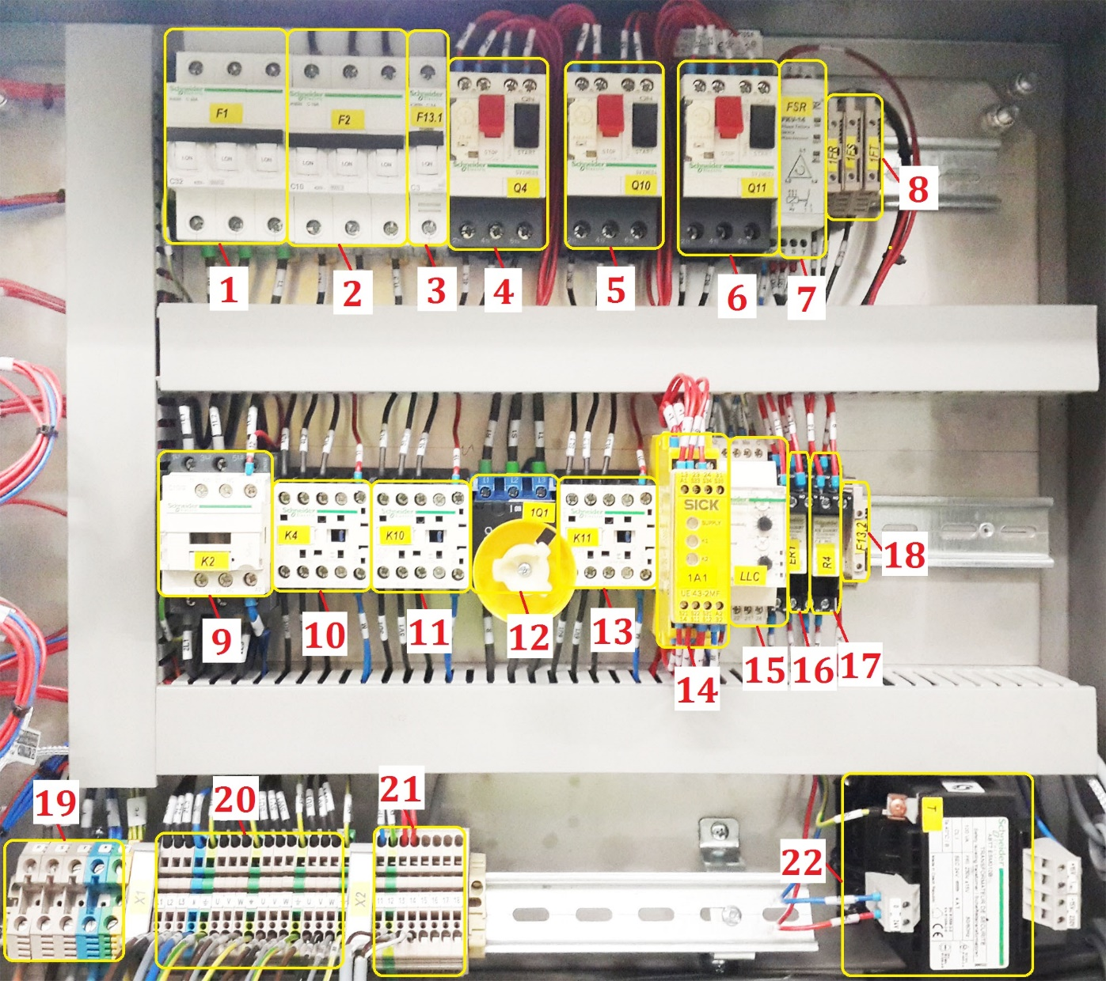

|  |  |  |  |  |  |  |  |
| --- | --- | --- | --- | --- | --- | --- | --- |
| **No** | **Component Name** | | **Mark** | | **Code** | | **Where Is The Using?** |
| 1 | Fuse | Schneider | | 3X32A | | Main Fuse | | |
| 2 | Fuse | Schneider | | 3X16A | | Heater Fuse | | |
| 3 | Fuse | Schneider | | 1X3A | | Transformer Input Fuse | | |
| 4 | Motor Safety | Schneider | | Gv2me08 | | Washing Pump Motor Safety | | |
| 5 | Motor Safety | Schneider | | Gv2me04 | | Reducer Motor Safety | | |
| 6 | Motor Safety | Schneider | | Gv2me03 | | Oıl Skımmer Motor Safety | | |
| 7 | Relay | Tense | | Fkv-14 | | Phase Safety Relay | | |
| 8 | Fuse | Weidmuller | | Wsı 6 | | Phase Safety Relay Output Fuse | | |
| 9 | Contactor | Schneider | | Lc1d18 | | Heater Contactor | | |
| 10 | Contactor | Schneider | | Lc1k09 | | Washing Pump Contactor | | |
| 11 | Contactor | Schneider | | Lc1k09 | | Reducer Contactor | | |
| 12 | Maın Switch | Kraus Naimer | | Kg 32 | | Maın Swıtch | | |
| 13 | Contactor | Schneider | | Lc1k09 | | Oıl Skımmer Contactor | | |
| 14 | Relay | Sick | | Ue43-2mf | | Emergency Stop Relay | | |
| 15 | Relay | Schneider | | Rm35lm | | Low Level Relay | | |
| 16 | Relay | Schneider | | Rsb 2a080b7 | | Emergency Stop Control Relay | | |
| 17 | Relay | Schneider | | Rsb 2a080b7 | | Tımer Control Relay | | |
| 18 | Fuse | Weıdmuller | | Wsı 6 | | Transformer Output Fuse | | |
| 19 | Clemens | Weıdmuller | | Wdu 6 | | Maın Power Input Clemens | | |
| 20 | Clemens | Weıdmuller | | Zdu 2,5 | | Component Input Clemens | | |
| 21 | Clemens | Weıdmuller | | Zdu 2,5 | | Control Component Input Clemens | | |
| 22 | Transformer | Schneider | | Abt7esm010b | | Control Transformer | | |

**5- INSTALLATION AND USAGE OF MACHINE**

* Firstly, eye control is made after the unpacking. If there is no problem, pass the construction stage.
* The machine is placed in level and stable position.
* Its location should be suitable for connections of electricity and liquid.
* Close drainage valves.
* The machine body is connected to the 3 phase electricity.
* The machine is connected to the 3 phase electric.
* The machine’s 3 phase electrical wiring must be completed according to the correct phase sequence.
* If the phase sequence is not connected correctly via the cable the energy will not pass once the confirmation button is pressed (or the machine don’t work).
* If the cables are connected in the correct phase sequence, the phase sequence relay “Out” light will lit.
* The draining pipe is connected to the sewerage system.
* Water level should be above from “water level sensor”.
* The pumps and resistances are protected from low liquid level. If there is not sufficient liquid in the tanks, they don’t work.
* Things to wash are placed into the machine basket.
* The cleaning water times and water temperature are set from the control panel.

**6- MACHINE MAINTENANCE**

* The following units are needed to the periodic maintenance.
* Pumps, filters, water level sensors, suction pipe, electric boards and main body.
* Pump pressure and flowrate should be checked regularly, if the pump pressure and/or flowrate is low.
* The pump gasket should be checked regularly and if it is needed should be changed.
* The pump’s fan gap can be clogged. It must be checked and cleaned.
* If the pump has water leak, the pump gasket can be wear out, it should be changed.
* Filters are maintenances while they are clogged or their permeability is low.
* Mesh filters are being washed with pressurized air and water regularly.
* The cleaning tanks should be cleaned periodically (weekly, monthly) according to the density of dirt and dregs. They can be cleaned with pressured water.
* Low water level relays must be checked or cleaned weekly. Dirt, grease and particles can be stop its up/down movement.
* If there is a water leakage, the leakprofing equipments must be checked. If it is needed, they changed with new ones.
* Suction pipes must be checked regularly.
* The machine body can be cleaned with maintenance sprays periodically.
* Electric boards can be cleaned with air or maintenance sprays.

**7- INSTRUCTIONS FOR PROBLEMS**

|  |  |  |
| --- | --- | --- |
| **Problem** | **Cause** | **What To Do** |
| The Pumps Don’t Work. | Liquid Level Is Under The Minimum Sufficient Level. | Add The Liquid To The Tanks. |
| The Thermic Fuse Is Blown. | Open Or Change Fuse With A New One. |
| The Fuse Is Blown. | Open Or Change Fuse With A New One. |
| Lid Switch May Not Be Closed Firmly. | Close The Switch Firmly. |
| Basket Rotation Reducer Doesn’t Work | The Thermic Fuse Is Blown. | Open Or Change Fuse With A New One. |
| The Fuse Is Blown. | Open Or Change Fuse With A New One. |
| V-Belt Is Loose Or Cut-Off | Tighten The V-Belt Or Change It With New One |
| Heating Resistances Don’t Work | Resistances Is Closed. | Resistances Can Be Opened From The Off/On Button. |
| Desired Value Is Smaller Than Current Value. | If Need, Increase The Desired Value. |
| Liquid Level Is Under The Minimum Sufficient Level. | Add The Liquid To The Tanks. |
| The Fuse Is Blown. | Open Or Change Fuse With A New One. |
| Oil Skimmer Doesn’t Work (Optional) | Cable Terminal Is Snug | Joint The Terminals. |
| Disk Is Jammed. | Tighten Or Loose The Disk Nut. |
| The machine does not receive confirmation once the confirmation button is pressed (light is not lit.) | The machine’s energy input phase sequence cables could be connected incorrectly. | Try changing the sequence of the phase sequence cables. |
| The phase sequence relay  fuse terminals remain in an open state. (Pg.10 – No:8) | Close the fuse terminals. |

**8- RECOMENDATIONS**

* Change The Cleaning Water When It Becomes Dirty.
* Do Not Splash Any Water To Control Panel During Water Filling.
* Do Not Replace Machine When It Is Working.
* Do Not Insert Your Hands Into The Tank When Machine Is Working.

**9- ATTENTIONS**

* When The Water Is Below Sufficient Level, Add Water To The Tank.
* Do Not Operate Machine Without Water Or With Low Water Level.
* Do Not Place Any Material Into The Tank Without Basket. All Things To Wash Must Be Placed In The Basket.
* Do Not Press The Buttons With A Sharp Object Or Any Pointed Instrument.
* After The Unpacking The Machine Please Check Again The Fitting Connections, Nuts, Screws, Valves… Etc. Which Has Possibility To Loosening. Because During The Transportation Machines Expose To Vibrations. After Checking And Fixing That Connection To Can Start To Installation.

***If You Have Any Problems With Machine Do Not Hesitate To Contact Us.***

**WE APPRECIATE YOU TO CHOOSE EVEREST ULTRASONİC CLEANING MACHINES.**

**CERTIFICATE OF GUARANTEE**

|  |  |  |  |
| --- | --- | --- | --- |
|  |  | MODEL | : **ESP 82** |
| GUARANTEE PERIOD : 2 YEAR |  | SERIAL NUMBER | : **140293** |
|  |  | BILLING DATE / Number | : **24 / 10 / 2014** |
|  |  | DELIVERY DATE | : **24 / 10 / 2014** |

|  |  |  |  |
| --- | --- | --- | --- |
| MANUFACTURER FIRM: | | SELLER FIRM: | |
| TITLE | E V E R ES T E L E K T RO M E K A N İ K  MAKİNE VE SİS. SAN. VE TİC. LTD. ŞTİ | TITLE |  |
| ADDRESS | BAĞCILAR GÜNGÖREN SANAYİ SİTESİ METRO IŞ MERKEZİ A BLOK NO:6-9  BAŞAKŞEHİR /İSTANBUL | ADDRESS |  |
| TEL | +90 212 671 25 85 | TEL |  |
| FAX | +90 212 671 25 89 | FAX |  |
| E-MAIL | [info@everestultrasonic.com](mailto:info@everestultrasonic.com) | E-MAIL |  |
| AUTHORIZED SIGNATURE AND STAMP | | AUTHORIZED SIGNATURE AND STAMP | |
|  | |  | |

**GUARANTEE CONDITIONS**

1. From the time the goods are delivered the guarantee is applied for 2 years.

2. All the parts of the goods are fully included in the guarantee.

3. If the machine breaks down during the guarantee period,the period for repair is included in the guarantee period.Guarantee period is for 30 working days.This period will start informing the service station,if there is no service station teh seller on agent ,supplier or one of the manufacturer.If the machine is not repaired in 15 working days,the supplier should supply another machine in its place.

4. During the guarantee period all repairs or replacement parts and working faults during installation all parts working costs will not be charged during repairments.

5. Goods;

— From the time that the goods are received,with the quarantee registered for one year if the same fault occurs,twice or more than four different times during the guarantee and averall mor ethan six faults you can benefit from the goods,

—Don’t exceed the maximum time of quarantee for repairing,

— Any faults reported to the agents representatives,suppliers and manufacturers,if unrepairable,replecement will be avaible or a refund of full cost or reduction an original price could be offered,

6.If the machine has broken down due to not following instructions in the guarantee bookler the manufacturer will not be responsible.

7. Within the guarantee period,from the service department,the manufacturers or suppliers with in the periodic condition the maintence given by the consumer any working or other charges will not be made.

**GUARANTEE CONDITIONS – NOTICE FOR PURCHASER**

1. If the guarantee of the product has not the original serial number or it has been altered then the guarantee will be invoid.

2. For the guarantee to be valid only Everest Elektromekanik authourized persons or authourized services but no other persons need to repair or make alterationsto the product

3. Authorized service indicates repair area and type (devices usage area or engineer’s workshop)

4. The conditions below do not apply to the faulty product in the guarantee;

a) Incorrect screw rigging(regulartor,continous power sources etc.)connecting together forms the faults,

b) Abnormal low voltage or high voltage,faulty power cuts and incorrect wiring which cause the faults,

c)After receiving the product any damage to the product(ie:dropping,extreme shaking,extreme banging)which produce the faults will not be covered,

d) Incorrect use of the product which cause the outside and inside surface to go bad,break or faulty,

e)Natural events(such as lighting,floods,earth quakes,fire etc.) causes damage,

f) Any faults occuring by deviation of the instruction manual is not covered.

